|  |  |
| --- | --- |
| Test Name | UC03 Scan Book |
| Use Case Tested: | Scan Book |
| Test Description: | Tests that a borrower who is not restricted is able to borrow a book. |
| Pre-conditions | The program has been started and initialised.  The “Borrow” button has been pressed.  The Borrower has swiped in and is not restricted.  The “Scanning” panel is active.  The “Scanner” is active. |
| Post-conditions | **Borrower has yet to reach their loan limit.**  System remains on the “Scanning” panel.  The Book scanner remains enabled.  The scanned Book’s details are displayed.  The new loan for the borrower is added to the Pending Loans list.  **Borrower reaches their loan limit.**  System shows the “Confirming Loans” panel.  The Book scanner becomes disabled.  The final “Pending Loan” list is displayed.  The Cancel button is enabled.  The Reject button is enabled.  **Book is not found.**  System remains on the “Scanning” panel.  The Book scanner remains enabled.  “Book not found” error is displayed.  **Book is not available.**  System remains on the “Scanning” panel.  The Book scanner remains enabled.  “Book not available” error is displayed.  **Book is already scanned.**  System remains on the “Scanning” panel.  The Book scanner remains enabled.  “Book already scanned” error is displayed. |
| Notes: | Special Requirement: That the test be repeatable, so multiple books can be scanned to the pending list. |

|  |  |  |
| --- | --- | --- |
| Data 1 Attempt – BOOK IS NOT AVAILABLE | |  |
| Result (Pass/Fail/Warning/Incomplete) | Pass | |

|  |  |  |  |  |
| --- | --- | --- | --- | --- |
|  | TEST STEP | EXPECTED TEST RESULTS | P | F |
|  | Borrower scans the book to be borrowed or enters the book number and presses “Scan Book” | System remains on the “Scanning” panel. | P |  |
|  |  | The Book scanner remains enabled. | P |  |
|  |  | “Book not available” error is displayed. | P |  |

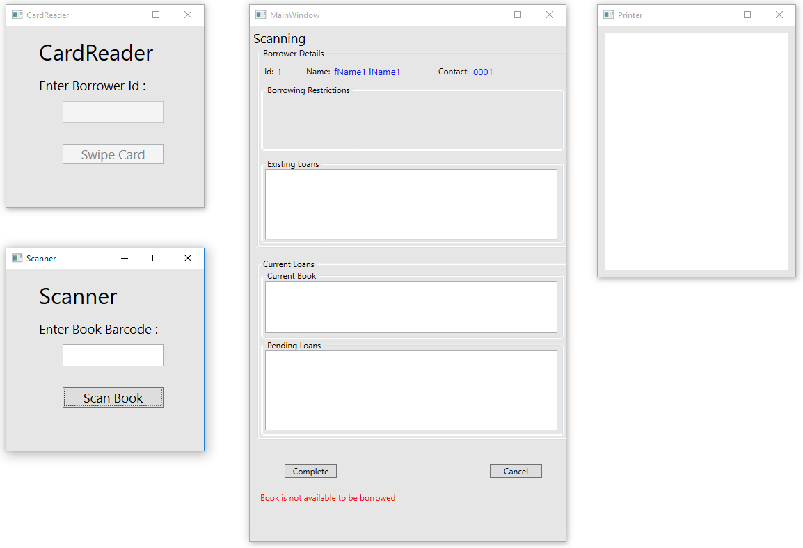

|  |  |  |
| --- | --- | --- |
| Data 2 Attempt – BOOK NOT FOUND | |  |
| Result (Pass/Fail/Warning/Incomplete) | Pass | |

|  |  |  |  |  |
| --- | --- | --- | --- | --- |
|  | TEST STEP | EXPECTED TEST RESULTS | P | F |
|  | Borrower scans the book to be borrowed or enters the book number and presses “Scan Book” | System remains on the “Scanning” panel. | P |  |
|  |  | The Book scanner remains enabled. | P |  |
|  |  | “Book not found” error is displayed. | P |  |

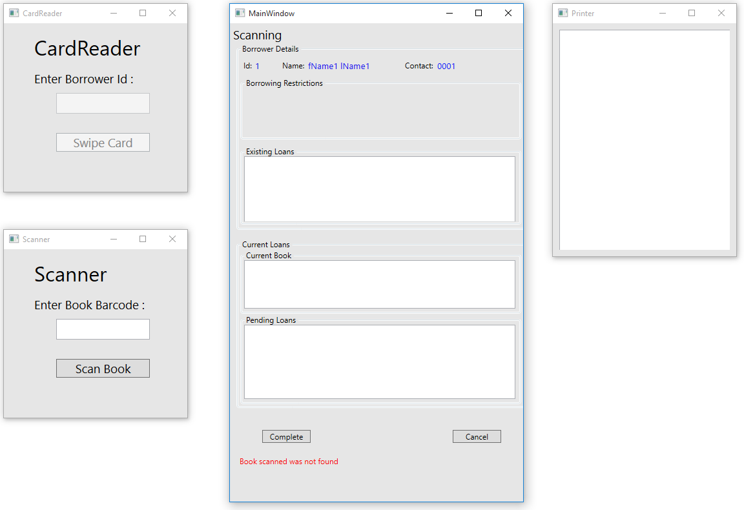

|  |  |  |
| --- | --- | --- |
| Data 3 Attempt – BOOK ALREADY SCANNED | |  |
| Result (Pass/Fail/Warning/Incomplete) | Pass | |

|  |  |  |  |  |
| --- | --- | --- | --- | --- |
|  | TEST STEP | EXPECTED TEST RESULTS | P | F |
|  | Borrower scans the book to be borrowed or enters the book number and presses “Scan Book” | System remains on the “Scanning” panel. | P |  |
|  |  | The Book scanner remains enabled. | P |  |
|  |  | “Book already scanned” error is displayed. | P |  |

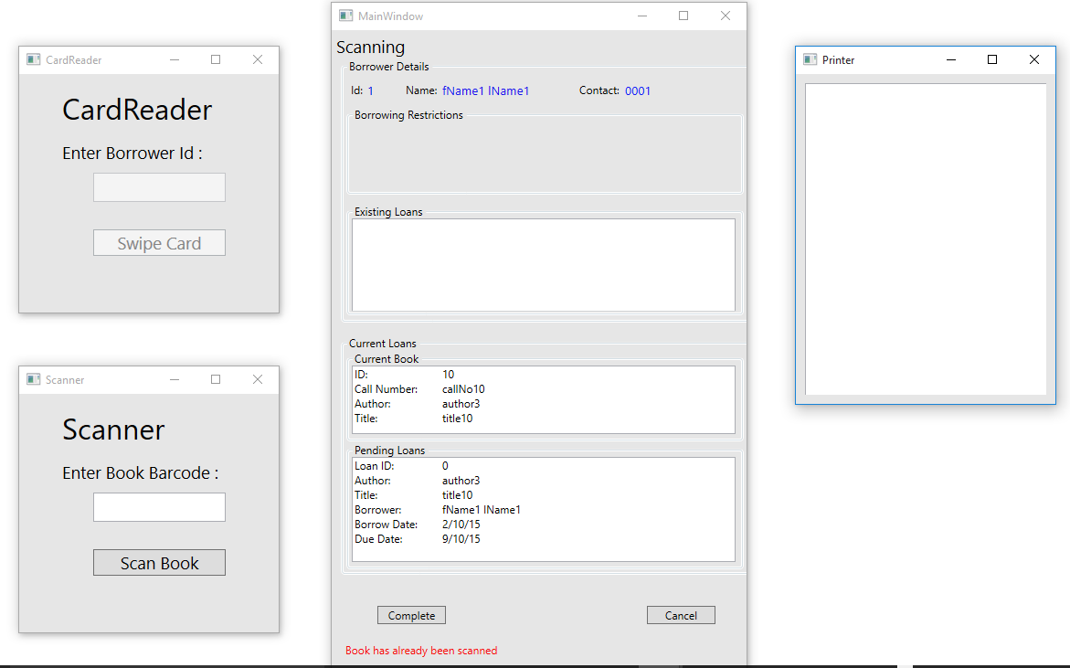

|  |  |  |
| --- | --- | --- |
| Data 4 Attempt – BORROWER YET TO REACH LIMIT | |  |
| Result (Pass/Fail/Warning/Incomplete) | Pass | |

|  |  |  |  |  |
| --- | --- | --- | --- | --- |
|  | TEST STEP | EXPECTED TEST RESULTS | P | F |
|  | Borrower scans the book to be borrowed or enters the book number and presses “Scan Book” | System remains on the “Scanning” panel. | P |  |
|  |  | The Book scanner remains enabled. | P |  |
|  |  | The scanned Book’s details are displayed. | P |  |
|  |  | The new loan for the borrower is added to the Pending Loans list. | P |  |

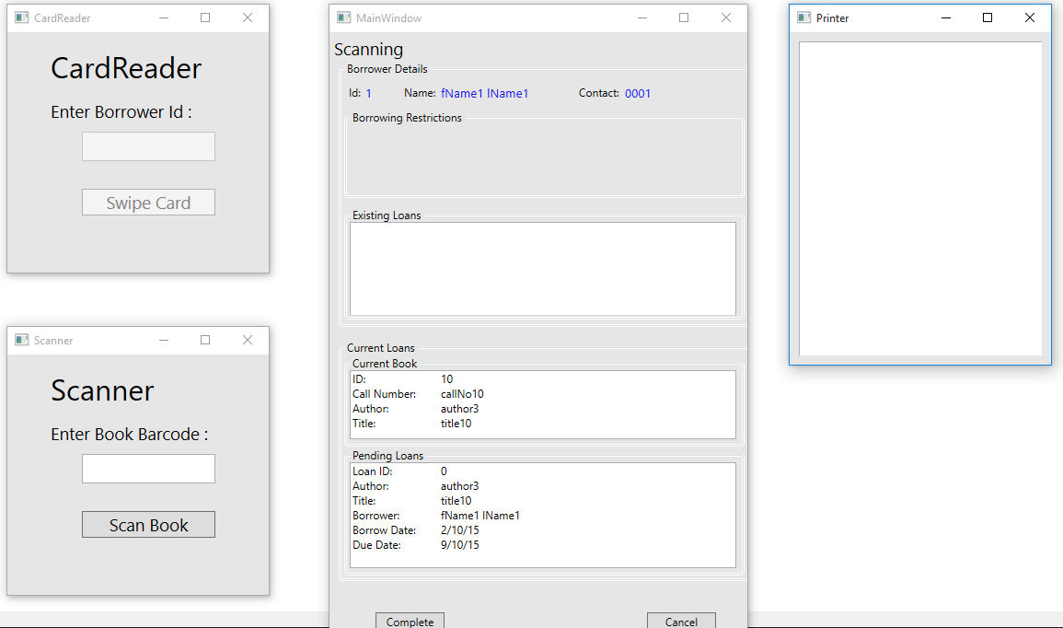

|  |  |  |
| --- | --- | --- |
| Data 4 Attempt – BORROWER YET TO REACHES LIMIT | |  |
| Result (Pass/Fail/Warning/Incomplete) | Fail | |

|  |  |  |  |  |
| --- | --- | --- | --- | --- |
|  | TEST STEP | EXPECTED TEST RESULTS | P | F |
|  | Borrower scans the book to be borrowed or enters the book number and presses “Scan Book” | System shows the “Confirming Loans” panel. | P |  |
|  |  | The Book scanner becomes disabled. | P |  |
|  |  | The final “Pending Loan” list is displayed. |  | F |
|  |  | The Cancel button is enabled. | P |  |
|  |  | The Reject button is enabled. | P |  |

Note: Only one loan is showing, not all pending loans.

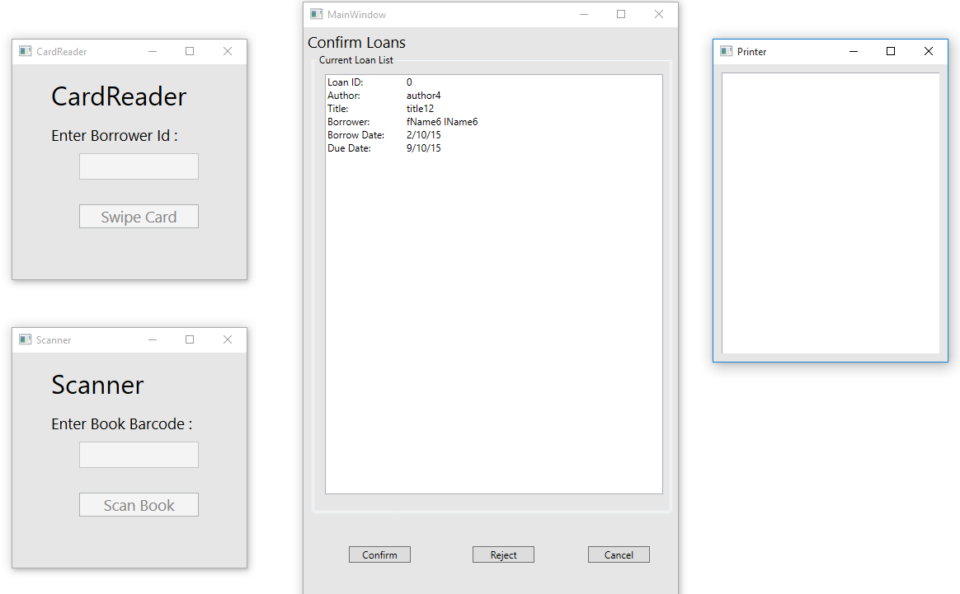

|  |  |  |  |  |  |
| --- | --- | --- | --- | --- | --- |
| Test Data Table | | | | | |
|  | **Member** | **Book** | **3** | **4** | **5** |
| Data 1 Attempt | 1 | 1 (1 – 9 give not available) |  |  |  |
| Data 2 Attempt | 1 | 30 |  |  |  |
| Data 3 Attempt | 1 | 10 |  |  |  |
|  | 1 | 10 |  |  |  |
| Data 4 Attempt | 1 | 10 |  |  |  |
| Data 5 Attempt | 6 | 10 |  |  |  |
|  | 6 | 11 |  |  |  |
|  | 6 | 12 |  |  |  |